Contents
Overview 1
Setup a Work group for standard non-pilot departments 2
Setup a Work group for Time and Absence pilot departments 3
Copy a Work group 5
Mark a Work group Inactive 5
Delete a Work group 6

Overview
The Work Group configuration screen is available via Portal on the WFM Admin Dashboard.
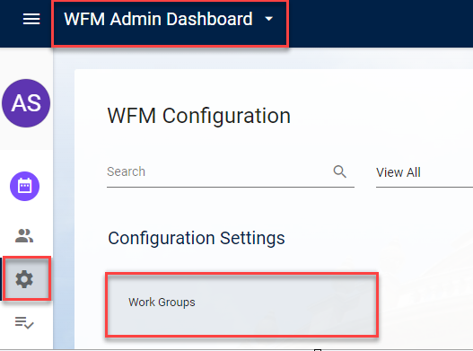

The following menu profile should be assigned in order to gain access to the steps below.
- WFM_WORKGROUP_CONFIG_ACCESS
The following menu options and webservices should be activated in order for you to gain access to the steps above.
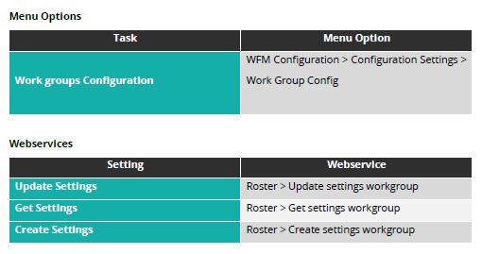

Setup a Work group for standard non-pilot departments
Navigate to WFM Admin Dashboard – WFM Configuration – select Work Group from under the Configuration Settings heading.
To add a new Work Group, click Add and enter the following details:
- Work Group Code (numeric, 6 digits)
- Description (Department Code must prefix all Work Group Descriptions, e.g. AA-Test)
- Company – enter 1 University of Oxford
- Holiday Scheme - enter HS001 Holiday Scheme
- Shift Type – enter 37.5HRS A-R Standard MON-FRI
- Timesheet – Test Timesheets
- Pay Frequency - Monthly User Defined Calendar
- Calculate Default Hours - set to NO.
- Generate Timesheets – YES
- Calculate Clockings - always enable, even if not clocking.
- Active
- OK to save
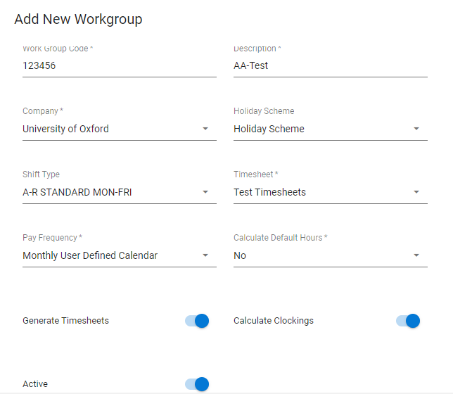
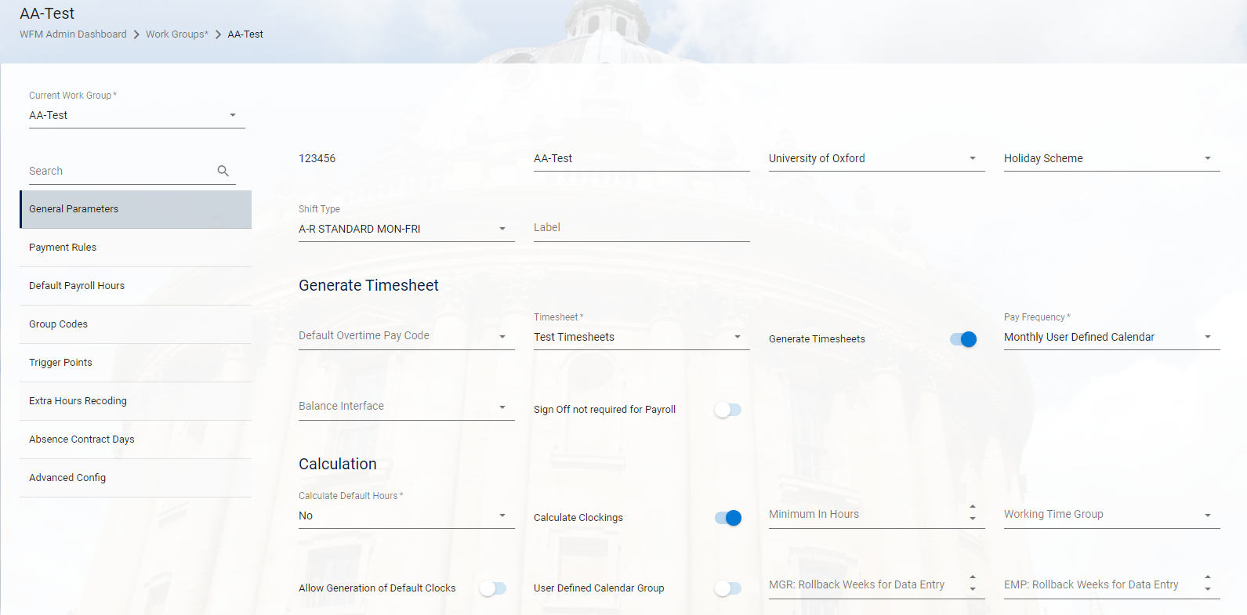

Setup a Work group for Time and Absence pilot departments
Navigate to WFM Admin Dashboard – WFM Configuration – select Work Group from under the Configuration Settings heading.
To add a new Work Group, click Add and enter the following details:
- Work Group Code (numeric, 6 digits)
- Description (Department Code must prefix all Work Group Descriptions, e.g. AA-Test)
- Company – enter 1 University of Oxford
- Holiday Scheme – as appropriate:

- NDM1 for Nuffield Department of Medicine departments
- UAS for those University Administration Services departments using Time and Absence.
- PHYSIC for Physics
- ACDEP1 for Classics departments
- ITSERV – IT Services Scheme - currently 3 UAS-Assurance departments only:
                - 104004-JB-SGR & C
                - 104003-JB-InfoSec
                - 104005-JB-Security Ops

- Shift Type – REST
- Timesheet – Live Timesheets
- Pay Frequency - Monthly User Defined Calendar
- Calculate Default Hours - set to NO.
- Generate Timesheets – YES
- Calculate Clockings - always enable, even if not clocking.
- Active
- OK to save
- General Parameters will open up next. Under Calculation heading, activate:
- ‘Allow Generation of Default Clocks’ toggle
- ‘User Defined Calendar Group’ toggle
- Save

- Within the Group Codes screen, select Manager from the ‘Personalised Payroll Group’ dropdown. Save.

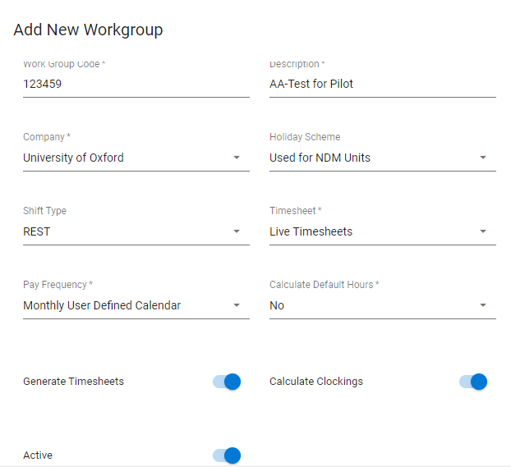
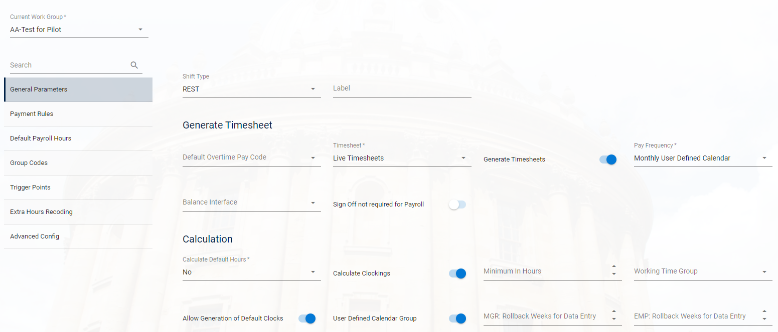

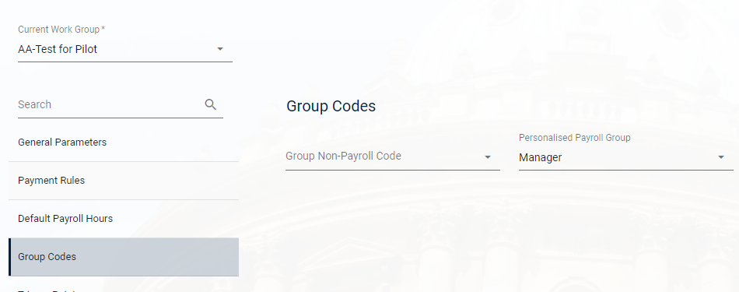

Copy a Work group
To Copy a Work Group:
1. Find a work group you wish to copy and select Copy Work group via the Breadcrumbs on the right of the screen.
A pop up appears which allows to enter a new work group code (6 digits) and description, click OK.
2. All the settings will be copied over to the newly created work group.
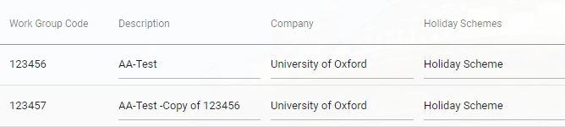

Mark a Work group Inactive
You can mark a Work Group as Inactive when it is no longer in use. This can only be done when there are no active employees assigned (but managers can be assigned).
Once inactive the work group no longer displays on the dropdown list of available work groups.
The Work Group screen is filtered only to display active Work Groups so in order to view Inactive Work groups, users can toggle the Active Indicator on the Filter seen in the screen shot above.
The Active toggle can be changed Inactive on the main landing page.

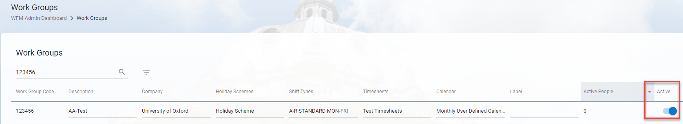

Delete a Work group
We can delete work groups that haven’t been assigned to any employees or managers.
Where there are Managers assigned to the work group, on deletion the below message will come up:
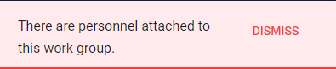
Where there are employees assigned to the work group, on deletion the below message will come up:
